Ireland Brook Conservation Area
Pollinator Habitat Enhancement Plan

Pollinator Habitat Enhancement Plan
Practice Activity Code (146)
Technical Service Provider ID: TSP-10-6572
Date Submitted: December 2017
Contents
Client Information 1
Plan Author(s) 1
Check Out and Signatures 1
Client Approval 2
Part 1. Background and site information 3
Farm Location 3
Location Map 3
Farm Overview 3
Parcel Map 3
Part. 2. Client Goals and Objectives 4
Part 3. Farm Inventory and Existing Conditions 6
Landscape Context 6
Farm Layout Map 6
Land Use and Crops 6
Pollinator Resource Inventory 7
Soils 8
Soils Map 8
Soils Map Legend 9
Existing Plant Community 10
Threatened and Endangered Species 10
Unique Habitat 10
Landscape Project Maps 11
Current Farm Management Practices 11
Habitat Assessment 12
Baseline Habitat Conditions 12
Resources Concerns 12
Part 4. Desired Future Conditions/Goals 13
Part 5. Pollinator Habitat Planning Documentation 14
Conservation Practice Maps 15
Tree/Shrub Establishment (612) 16
Current Conditions 16
Desired Future Conditions 16
Definition and Purpose 17
Plant Selection 18
Installation Plan and Timeline 20
Site Preparation: Basic Instructions 20
Planting Method 20
Planting Dates 21
Planting Density 21
Management During Establishment 21
Long-Term Management 21
Operations and Maintenance 23
Conservation Cover (327) for Pollinators 24
Current Conditions 24
Desired Future Conditions 24
Definition and Purpose 25
Plant Selection 25
Installation Plan and TimeLine 27
Site Preparation: Basic Instructions 27
Planting Method 28
Planting Dates 28
Seeding Rate 28
Instructions for Broadcast Seeding 29
Management During Establishment 29
Operations and Maintenance 30
Hedgerow Planting (422) for Pollinators 31
Current Conditions 31
Desired Future Conditions 32
Definition and Purpose 32
Plant Selection 33
Installation Plan and Timeline 38
Site Preparation: Basic Instructions 38
Planting Method 38
Management During Establishment 39
Operations and Maintenance 39
Pesticide Protection for Pollinators 40
Priority pesticide concerns 40
Insecticides 40
Fungicides 40
Herbicides 40
Common Ways Pesticides can Move into Habitat 41
Guidance to Protect Habitat from Pesticide Contamination 41
Monitoring and Record Keeping 42
Appendix 42

Client Information
Client/Organization Name(s): Open Space Conservation Cooperative
Ines Zimmerman, District Manager, Freehold Soil Conservation District, NJ & Open Space Conservation Cooperative Coordinator
Email: Izimmerman@freeholdscd.org, Phone: (732) 683-8500
Farm Name: Ireland Brook Conservation Area
Farm Address: East Brunswick and South Brunswick Townships
Parking Area Address: 581 Riva Avenue, East Brunswick (main access)
Parking Area Address: 99 Parkview Court, South Brunswick

Plan Author(s)
Eric Lee-Mader, Pollinator Program Co-Director, The Xerces Society
Technical Service Provider ID: TSP-10-6572
Address: 628 NE Broadway, Suite 200, Portland, Or 97232
Email: eric@xerces.org, Phone: 855-232-6639
Kelly Gill, Pollinator Conservation Specialist, The Xerces Society
Address: 628 NE Broadway, Suite 200, Portland, Or 97232
Email: kelly@xerces.org, Phone: 515-708-6108

Check Out and Signatures
I certify that the following pollinator habitat conservation plan meets the requirements of the USDA Environmental Quality Incentives Program and the quality criteria for a Conservation Activity Plan (Code 146) in Section III of the USDA NRCS Field Office Technical Guide.
Plan Author(s): Date:
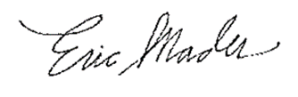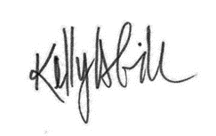

Client Approval
I have reviewed this plan and I believe the management recommendations will help me meet my goals and objectives for my property. I agree to follow this plan to ensure the sustainability of my management.

Landowner:_____________________________________________Date:________________

Part 1. Background and site information

Farm Location
Address: East Brunswick and South Brunswick Townships, NJ
Parking Area Address: 581 Riva Avenue, East Brunswick (main access)
GPS Coordinates: 40° 25' 17.5944"N, -74 °28' 58.7352"W
Parking Area Address: 99 Parkview Court, South Brunswick
GPS Coordinates: 40° 24’ 52”N, -74° 28’ 46”W
County: Middlesex
District: Freehold Soil Conservation District, Freehold USDA Service Center
CLU: Tracts included in this plan = 291, 757, 1219
Total Acres: 445 (Cropland = 18 ac., Grassland = 16 ac., Forest = 410.59 ac.)

Location Map
Farm Overview
Ireland Brook Conservation Area is a 445-acre property located in Middlesex County, NJ. The property is primarily forest, but also includes cropland, grassland, and shrubland. Currently, Middlesex County owns Ireland Brook Conservation Area and it is one of county’s parks/open space areas. The property is open to the public for passive recreation such as hiking and birdwatching. Agricultural fields are rented by local farmers.

Parcel Map
The NRCS property map with FSA Common Land Unit designations is provided in the appendix of this plan.

Part. 2. Client Goals and Objectives
The Open Space Conservation Cooperative’s (OSCC) mission is to provide assistance to open space landowners on managing preserved land productively. The OSCC selected Ireland Brook Conservation Area as a priority site for natural resources conservation assistance based on current conditions and proximity (two-mile radius) to existing agricultural land, preserved farmland, threatened and endangered species, and riparian zones. The overall goal OSCC is to be proactive in implementing land management practices that protect natural resources, biodiversity, and maintain (and improve) the site’s conservation value. Specific priorities for Ireland Brook Conservation Area include establishing shrub habitat in old agricultural fields, enhancing pollinator habitat in grasslands, improving streams and riparian areas, invasive species management, and wildlife management and Endangered Species conservation. Pollinator conservation objectives for this plan are summarized below.
1. Enhance Habitat to Support a Diversity of Native Pollinators
Native (wild) bees are important pollinators of wild and cultivated plants. Other flower-visiting insects such as flies, wasps, butterflies, moths, and beetles also contribute to pollination. Most flowering plants are visited by a variety of pollinators, while other flowers are precisely matched to a single species or certain group pollinators. Supporting a diversity of pollinators in the landscape is essential for maintaining productive cropland and natural plant communities. Habitat enhancements recommended for this objective include:
- Increasing the abundance and diversity of native flowering plants and ensuring the availability of continuous and bloom to provide nectar and pollen resources throughout the seasons.
- Increasing nesting opportunities for solitary ground-nesting, tunnel-nesting bees, and bumble bees.
- Increasing the abundance and diversity of butterfly larval host plants.
- Increasing permanent cover and enhancing vegetative structure for shelter and overwintering habitat.
2. Protect Pollinators from Land Use Impacts
Pollinators and other beneficial insects need protection from pesticides and land use impacts (e.g., tillage and mowing). Incorporating techniques that prevent or reduce risks associated with land management practices is a high priority on every farm. For conservation to be successful, pollinators must be properly protected from harmful disturbances. Land management considerations for this objective include:
- Reducing disturbance or harm from farm practices (e.g., tillage, mowing, irrigation).
- Preventing or mitigating potential impacts of pest management practices on pollinators, including preventing exposure to pesticides via direct contact, drift, and/or habitat contamination.
3. Wildlife Management
The habitat enhancements recommended for pollinators can also benefit other wildlife. Considerations for this objective include selecting native plant species that benefit pollinators and provide food (e.g., fruits or seeds), cover, and stratification of habitat to benefit beneficial insects, songbirds, gamebirds, amphibians, and other animals that share the same habitat. Habitat enhancements recommended for this objective include:
- Selecting plants with high wildlife value.
- Creating shrub/scrub habitat that benefits pollinator and other wildlife.
- Improving vegetative structure and vertical layering of habitats.
4. Protection of Threatened and Endangered Species
Ireland Brook Conservation Area and the surrounding areas were assessed for Threatened or Endangered species using NJ Landscape Project map layers. The map showed the silver-bordered fritillary butterfly (Boloria selene) was recorded within a two-mile radius of the farm. This butterfly was once found statewide, but in recent years, populations have declined significantly in NJ. Recent observations are limited to a few counties (Middlesex, Monmouth and Sussex). The silver-bordered fritillary is now listed as a state-Threatened species. Declines are thought to be a result of loss of wetland habitat and the negative effects of insecticide use to control mosquitos. It is unknown if this species has been observed on Ireland Brook Conservation Area, but the wet, open areas on the farm can be suitable habitat for this rare species. The silver-bordered fritillary is one of many wetland-associated species experiencing drastic declines. Pollinator habitat recommendations in this plan will include considerations for this species.
5. Invasive Species Management
Invasive plant species are present on the farm. Unmanaged invasive species can have negative ecological consequences as these plants can spread rapidly, dominate/exclude native plant communities, and displace associated wildlife. Invasive species management is a critical consideration in managing existing habitat and will be required for establishing and maintaining new pollinator habitat. Considerations for this objective include management recommendations for managing invasive species in areas proposed for habitat enhancements to ensure successful establishment of desirable plant communities and long-term function of habitat installations.
6. Addressing Multiple Resource Concerns
Pollinator habitat enhancements can be designed for multiple conservation benefits. For instance, permanent plantings of native plants that benefit pollinators can be installed in the riparian areas to reduce erosion, improve water quality, and benefit other wildlife. Considerations for this objective include designing and installing habitat for multiple benefits where applicable.

Part 3. Farm Inventory and Existing Conditions
Existing conditions and current management practices at Ireland Brook Conservation Area were documented during site visits. This section provides a summary of the property inventory, current conditions, habitat assessment scores, and resource concerns.

Landscape Context
Ireland Brook Conservation Area is located in central NJ, in East Brunswick and South Brunswick Twp. The landscape surrounding the property includes developed areas, open space/parks, agricultural lands, and forest. Ireland Brook runs through the property. To the north of the property is Tamarack Hollow Preserve and to the west is Davidson Mill Pond County Park, which also provides green/open space areas nearby. These parks form a “green-belt” of over 1,500 ac. in East and South Brunswick.

Farm Layout Map
The Farm Layout Map shows the property boundaries and land use at Ireland Brook Conservation Area. Note: Copies of the NRCS property maps and Farm Layout Maps are also provided in the appendix of this plan.

Land Use and Crops
Most of the acres on Ireland Brook Conservation Area are forestland (~410 ac.). There are hiking trails on the property that are open to the public. Smaller fields (~18 ac. total) are rented to a local farmer for crop production. Crops grown on the farm include sweet corn and pumpkins. The county encourages farmers that rent county owned land for agricultural use to implement conservation tillage practices in their farm management operations.

Pollinator Resource Inventory
Pumpkins grown on the farm require pollination by insects to produce fruits. Inadequate pollination can result in fewer fruits or seeds, or smaller or misshapen fruits. Insect pollinators are essential to pumpkins, squash, and other vine crops (e.g., cucumber, watermelon). The value of pollination services is well recognized for production of marketable fruits in these crops. Research shows that a variety of pollinators are visiting these crops and contributing to pollination services needed for profitable yields.
Squash bees, Peponapis and Xenoglossa species, are considered to be among the most effective pollinators of cucurbits. They nest underground at the base of the crop plant and emerge to visit blossoms early in the morning, often before sunrise and before other bee species start foraging for the day. Squash bees rapidly colonize new pumpkin plantings, and prosper in no-till or reduced tillage cropping systems. Bumble bees (Bombus spp.) and various sweat bees (Halictidae) are also common squash pollinators. Cucurbits require high pollinator activity to produce marketable fruits. The plants are monoecious (bearing separate male and female flowers on the same plant) and insects are required to move large quantities of pollen from male flowers to female flowers. When flowers do not receive sufficient amounts of pollen, the result is misshapen fruit. Flowers without any bee visitation abort and do not produce fruit. Many commercial squash producers rent honey bees to ensure adequate pollination without recognizing the presence of squash bees and other wild species that are already pollinating cucurbit crops. Sweet corn is wind pollinated, but bees visit plants to collect pollen when other flowering plants are scarce.
Many wild plants at Ireland Brook Conservation Area also require pollination to produce fruits, berries, and seeds that are important foods for wildlife such as migratory songbirds, gamebirds, and small mammals. Some of these wild plants are also food sources, have medicinal value, or are culturally important to humans. Open pollination of wild plants by insects is essential for maintaining genetic diversity in our plant communities. Therefore, pollinators are an important resource for biodiversity conservation on the property.
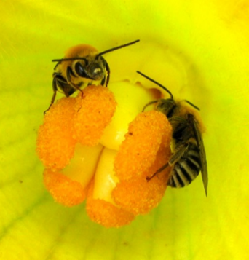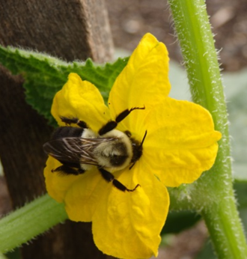
Left to right: Squash bees (Peponapis pruinosa) and bumble bee (Bombus sp.) visiting cucurbit crops. Photos: The Xerces Society/ Nancy Lee Adamson.

Soils
Soils on the farm are primarily well-drained, sandy loam soils with Woodstown sandy loam (WoeA and WoeB) being the dominant soil type in the agricultural fields. There are areas of poorly drained soils including Humaquepts soils, which have a hydric soils rating. Wetlands (e.g., ponds, vernal pools) are present on the farm. The full Custom Soil Resource Report for Ireland Brook Conservation Area is provided in the appendix of this plan.

Soils Map
The soils map shows the delineation and taxonomic classification of soil types on Ireland Brook Conservation Area. Note: Map resized to fit page. A to-scale copy of the soils map is provided in the appendix of this plan.
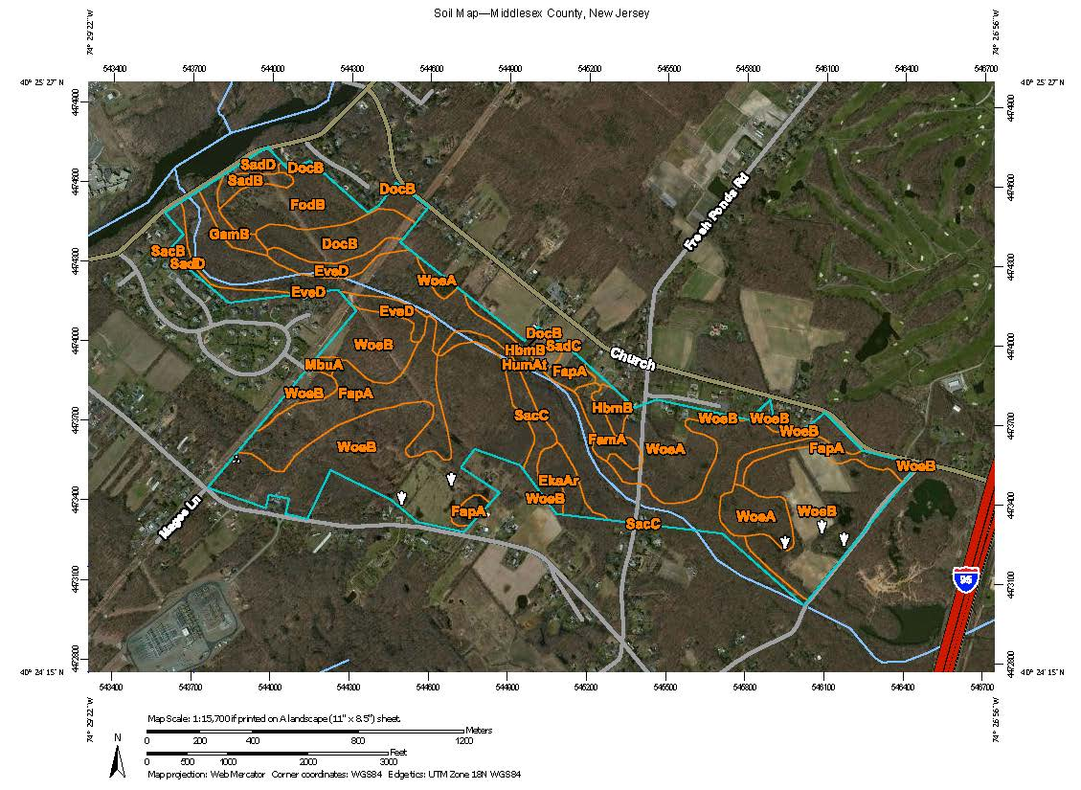

Soils Map Legend
Map Unit Symbol | Map Unit Name | Acres in AOI | Percent of AOI
DocB | Downer loamy sand, 0 to 5 percent slopes  Northern Coastal Plain | 18.3 | 4.1%
EkaAr | Elkton loam, 0 to 2 percent slopes  rarely flooded | 7.1 | 1.6%
EveD | Evesboro sand, 10 to 15 percent slopes | 12.0 | 2.7%
FamA | Fallsington sandy loams, 0 to 2 percent slopes  Northern Coastal Plain | 7.3 | 1.6%
FapA | Fallsington loams, 0 to 2 percent slopes  Northern Coastal Plain | 48.8 | 11.0%
FodB | Fort Mott loamy sand, 0 to 5 percent slopes | 24.0 | 5.4%
GamB | Galloway loamy sand, 0 to 5 percent slopes | 4.8 | 1.1%
HbmB | Hammonton loamy sand, 0 to 5 percent slopes | 8.7 | 2.0%
HumAt | Humaquepts, 0 to 3 percent slopes  frequently flooded | 93.4 | 21.0%
MbuA | Mattapex silt loam, 0 to 2 percent slopes  Northern Coastal Plain | 1.4 | 0.3%
SacB | Sassafras sandy loam, 2 to 5 percent slopes  Northern Coastal Plain | 0.0 | 0.0%
SacC | Sassafras sandy loam, 5 to 10 percent slopes  Northern Coastal Plain | 11.9 | 2.7%
SadB | Sassafras gravelly sandy loam, 2 to 5 percent slopes | 4.2 | 0.9%
SadC | Sassafras gravelly sandy loam, 5 to 10 percent slopes | 0.0 | 0.0%
SadD | Sassafras gravelly sandy loam, 10 to 15 percent slopes | 8.4 | 1.9%
WoeA | Woodstown sandy loam, 0 to 2 percent slopes  Northern Coastal Plain | 39.5 | 8.9%
WoeB | Woodstown sandy loam, 2 to 5 percent slopes  Northern Coastal Plain | 155.9 | 35.0%
 | Totals for Area of Interest | 445.9 | 100%

Existing Plant Community
Common native plants with value to pollinators (and other wildlife) documented at Ireland Brook Conservation Area include the following:
Wildflowers: yellow false indigo (Baptisia tinctoria), dogbane* (Apocynum cannabinum), yarrow (Achillea millefolium) common milkweed (Asclepias syriaca), common cinquefoil (Potentilla simplex), henbit (Lamium amplexicaule), white snakeroot (Ageratina altissima), goldenrod (Solidago spp.), coastal violet** (Viola brittoniana), primrose-leaf violet** (Viola primulifolia), white wood aster (Eurybia divaricata). *A. cannabinum can become weedy. ** Host plant for fritillary butterflies including the silver-bordered fritillary.
Grasses and sedges: broomsedge (Andropogon virginicus), poverty oatgrass (Danthonia spicata), purple lovegrass (Eragrostis spectabilis), Pennsylvania sedge (Carex pensylvanica).
Trees and shrubs: flowering dogwood (Cornus florida), swamp dewberry (Rubus hispidus), red cedar (Juniperus virginiana), American beech (Fagus grandifolia), red maple (Acer rubrum), oak (Quercus spp.), sweetgum (Liquidambar styraciflua), black cherry (Prunus serotina), sumac (Rhus spp.), sweetpepper bush (Clethra alnifolia), Northern bayberry (Myrica pensylvanica).
Common weeds at Ireland Brook Conservation Area include:
Common reed (Phragmites australis), multiflora rose (Rosa multiflora), autumn olive (Elaeagnus umbellata), Japanese honeysuckle (Lonicera japonica), Japanese barberry (Berberis thunbergii), knotweed (Fallopia japonica), mugwort (Artemisia vulgaris), plantain (Plantago sp.), garlic mustard (Alliaria officinalis), and non-native cool-season grasses.
Note: Plant species list is not exhaustive. Plant species inventory was focused in the area along forest edges/field borders surrounding the agricultural fields (i.e., priority areas selected for the Pollinator Habitat Enhancement Plan).

Threatened and Endangered Species
Ireland Brook Conservation Area and the surrounding landscape are within the range of the silver-bordered fritillary butterfly (Boloria selene). The silver-bordered fritillary formerly occurred in most NJ counties, but is now known in only a few counties including Middlesex County. This butterfly inhabits moist open areas such as sedge meadows, bogs, and other wet habitats. It is unknown whether the silver-bordered fritillary butterfly is present on or near the farm; however, the wet areas of the farm have potential to provide habitat for this locally rare species. Silver-bordered fritillary caterpillars use violets (Viola spp.) as larval food plants (also present on the property). Favorite nectar sources for adults are composite flowers, such as blackeyed susan (Rudbeckia hirta) and goldenrods (Solidago spp.).

Unique Habitat
Open habitats (e.g., grasslands and shrublands) are present on Ireland Brook Conservation Area and can be enhanced or managed to better support wildlife. Protecting open habitat such as meadows and shrubland is a widespread conservation priority in the region. In eastern North America, open shrubland have declined by 98 percent in the past 60 years. Over half (22/40) of bird species associated with eastern N. American shrublands are experiencing significant population declines. Furthermore, shrubland habitats have a higher proportion of state-listed butterflies and moths than other natural community types. For example, in the Northeast, 58 species of butterflies and moths are dependent upon shrubland habitat, and almost all of these species (56 of 58) are considered rare. Rapid and widespread loss of shrubland and meadows and the detrimental effects on associated wildlife makes protecting and managing these habitats a conservation priority. OSCC identified the creation/enhancement of shrubland at Ireland Brook Conservation Area as one of the conservation priorities for the property.
The wetland areas on or surrounding the farm, especially vernal habitats (i.e., vernal pools and adjacent wetlands) have high habitat value. There are seven species of amphibians in NJ that are obligate vernal pool breeders and several other species are facultative vernal pool breeders or seasonal inhabitants of vernal pools. Many of these animals are listed as Threatened or Endangered species. These are important habitats for spotted salamander, wood frog, and spring peepers found on Ireland Brook Conservation Area. Therefore, the wetlands, ponds, and vernal pools on the property offer important and unique habitat and management practices should consider the protection of this critical habitat.

Landscape Project Maps
The following Landscape Project maps show the location of vernal habitat and water bodies on Ireland Brook Conservation Area Note: Maps resized to fit page. To-scale copies of Landscape Project Maps are provided in the appendix of this plan.
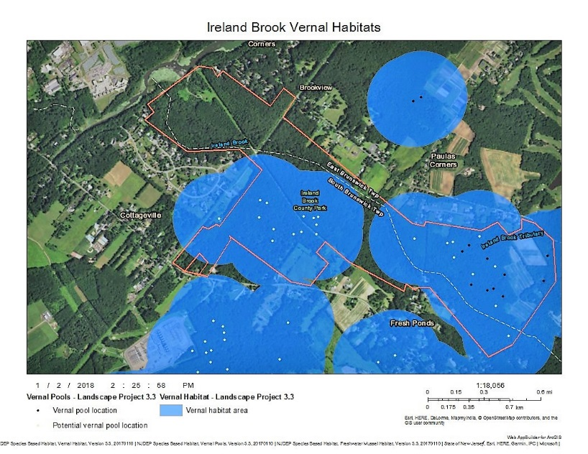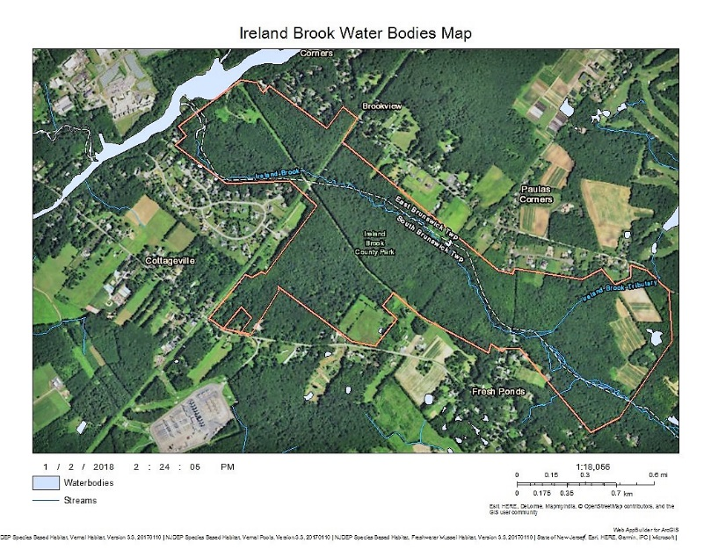

Current Farm Management Practices
Farmers that manage cropland on county-owned land, including Ireland Brook Conservation Area, are encouraged by the county to use conservation tillage practices that promote soil health and protect water quality. Herbicide treatments (broadcast application) are applied to crop fields as needed to control competition from weeds. In non-cropped areas (e.g., field borders, forestland) targeted herbicide application and mechanical weed control methods are used to manage invasive species.

Habitat Assessment
The Xerces’ Society Pollinator Habitat Assessment Form and Guide for Farms and Agricultural Landscapes was used to evaluate the condition of pollinator habitat in the planning unit. The assessment provides a before score based on current conditions and this score is used to identify and prioritize actions (treatments) that address the resource concerns documented at Ireland Brook Conservation Area. The planned score represents the potential increase in scores that can be achieved after this plan is implemented. Scores are summarized in the following table and the full Pollinator Habitat Assessment Form and Guide is included in the appendix of this plan.

Baseline Habitat Conditions
POLLINATOR HABITAT ASSESSMENT SUMMARY
Conditions Assessed | Existing | Planned
Section 1: Landscape Features | 10 | 10
Section 2: Farmscape Features | 17 | 35
Section 3: Foraging Habitat | 13 | 29
Section 4: Nesting Habitat | 19 | 35
Section 5: Farm Practices | 12 | 33
Summary Score | 71 | 142

Resources Concerns
The pollinator habitat assessment shows a resource concern regarding inadequate habitat for pollinators. Current habitat for pollinators at Ireland Brook Farm is limited (in both time and space). A few high-value pollinator plants were documented on site, but were not abundant and there are gaps in bloom. Habitat structure and connectivity on the farm can also be improved to better support pollinators. Priority resources concerns include:
Inadequate Habitat for Fish and Wildlife – Habitat Degradation
Quantity and/or quality of food is inadequate to meet the life history requirements of the species or guild of species of concern; cover/shelter for the species or guild of species of concern is unavailable or inadequate (e.g., lack of hiding, thermal, and/or refuge cover); habitat has insufficient structure, extent, and connectivity to provide ecological functions and/or achieve management objectives.
Degraded Plant Condition – Inadequate Structure and Composition
Plant communities have insufficient composition and structure to achieve ecological functions and/or management objectives; invasive and noxious plant species are present on site.
To address these resource concerns, recommended practices included in this plan are designed to improve the availability and arrangement of food, water, cover, shelter, and habitat continuity on the farm. These practices include conserving existing habitat and installing new habitat. Actively managing habitat on the farm is essential to in attaining population stability in the long term. Recommended practices are detailed in Part 5. Pollinator Habitat Planning.

Part 4. Desired Future Conditions/Goals
The overall goal of OSCC is to improve the existing conditions and environmental quality of Middlesex County Parks and Open Spaces. To meet pollinator conservation goals, the following alternatives are proposed as desired future conditions for Ireland Brook Conservation Area:
- The plant species composition benefits a diverse pollinator community.
  - Permanent vegetation, including a mix of native grasses and wildflowers that provides habitat for pollinators is established and maintained.
  - Habitat includes a minimum of 12 species of native (herbaceous) wildflowers and at least 3 species are blooming at any one time to provide season-long bloom.
  - Habitat includes native flowering shrubs and trees that bloom in early spring.
  - Habitat includes plants and structures that provide nesting and overwintering sites.
  - Habitat includes larval host plants for butterflies.
- Large areas of undisturbed pollinator habitat are available.
  - No tillage in areas appropriate for ground-nesting bees.
  - Vegetation management is conducted to maintain desired plant community and management activities occur at times that reduce negative impacts on pollinators.
- Riparian area improvements (i.e., hedgerow plantings) include:
  - Shrub layer is established/enhanced with native flowering shrubs.
  - Herbaceous layer near riparian buffers are enhanced with native bunch grasses.
  - Riparian enhancements also benefit water quality, wildlife, and other natural resources.
- Pollinators and their habitat are protected from pesticide exposure.
  - Habitat is protected from insecticide contamination from drift or overspray.
  - Spray setbacks are used to prevent herbicide or insecticide drift onto habitat adjacent to crop fields.
- A plan for monitoring and controlling invasive plant species is developed and implemented.
- Operation and maintenance schedules for conservation practices are followed and adapted as needed to ensure the practice functions as intended.
- Recordkeeping is included as part of the long-term management plan.

Part 5. Pollinator Habitat Planning Documentation
The following habitat enhancements and management practices are recommended to address pollinator habitat resource concerns at Ireland Brook Conservation Area (plans and specifications provided below). *Note: Locations and size of habitat installations can be adjusted to meet landowner’s needs or accommodate farm practices/other land use (e.g., hiking trails). Practices can be installed on other areas of the property where the same resource concern exists.
Shrub Establishment - Establish native flowering shrubs in groups/clumps to create open shrubland habitat interspersed with herbaceous vegetation.
- Proposed NRCS conservation practice: Tree/Shrub Establishment (612)
- Proposed location(s): Tract 1219, Field 3. Each shrub grouping (i.e., Motts) is 50 ft. in diameter with 4 Motts per acre (8 total over 2 ac. is proposed in this plan) as shown on the Conservation Practice Maps. Total area ~ 0.36 ac.
Wildflower Planting – Establish a diverse mix of native wildflowers and bunch grasses for pollinators.
- Proposed NRCS conservation practice: Conservation Cover (327) for Pollinators.
- Proposed location(s): Tract 1219, Field 3 (2.0 ac.), Tract 757, Field 3 (2.5 ac.), and Tract 757, Field 4 (1.0 ac.) as shown on the Conservation Practice Maps. Total area ~ 5.5 ac.
Hedgerow Planting – Establish native flowering shrubs and small trees for pollinators along field borders and riparian areas.
- Proposed NRCS conservation practice: Hedgerow Planting (422) for Pollinators.
- Proposed location(s): Tract 757, Field 4 (700 ft. L x 15 ft. W), Tract 291, Field 3 (450 ft. L x 15 ft. W), Tract 291, Field 4 (1,400 ft. L. x 15 ft. W), Tract 291, Field 5 (800 ft. L x 15 ft. W) as shown on the Conservation Practice Maps. Total area ~ 1.14 ac.
Pesticide Risk Mitigation – Protect pollinators and other beneficial organisms by preventing or reducing risk associated with harmful pesticides and protect habitat from pesticide contamination.
- This practice is proposed for all areas of the property where pesticides are used.

Conservation Practice Maps
The Conservation Practice Maps show the proposed locations for pollinator habitat enhancements listed above. Note: Copies of the Conservation Practice Maps are provided in the appendix of this plan.

Tree/Shrub Establishment (612)
Establish and maintain groups/clumps of native shrubs interspersed with herbaceous openings to create early successional habitat. Select a combination native species that provide pollen- and nectar-rich forage, nesting sites, and overwintering refuge for pollinators. Many shrub species bloom earlier in spring when wildflowers are scarce/not blooming yet. Therefore, enhancing habitat with native shrubs provides nectar and pollen in early spring and enhances diversity of flowering plants for continuous bloom. At Ireland Brook Conservation Area, shrub planting will also increase structural diversity and vertical layering of habitats (i.e., habitat stratification). Supporting practices such as Tree/Shrub Site Preparation (490) and Mulching (484) may be available through NRCS programs.

Current Conditions
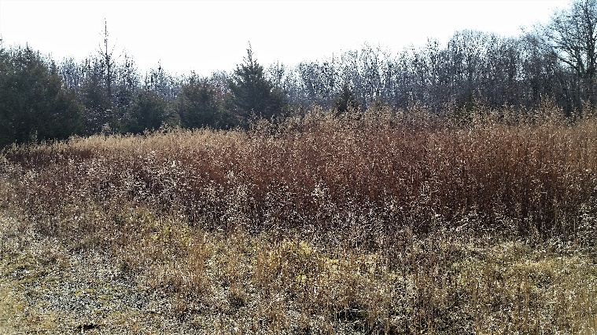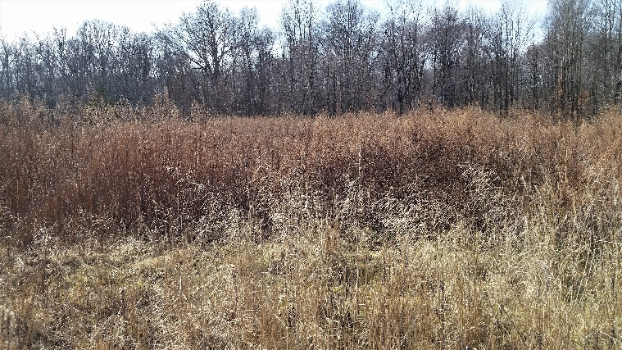
The pictures above show old field areas at Ireland Brook Conservation Area that are dominated by invasive species, namely mugwort and non-native cool-season grasses. These areas can be enhanced and managed to support native plant communities composed of clumps of shrubs and herbaceous openings.

Desired Future Conditions
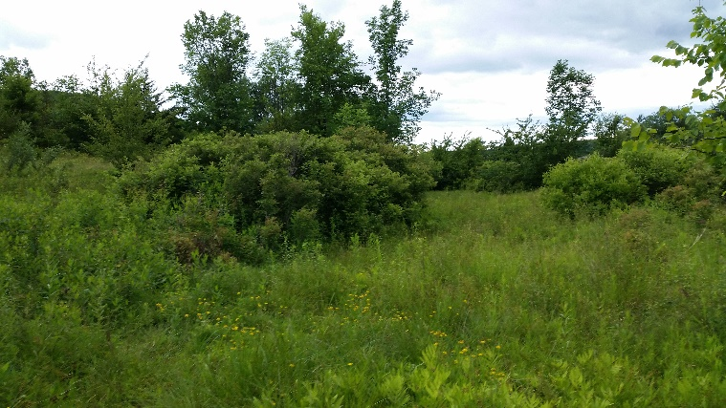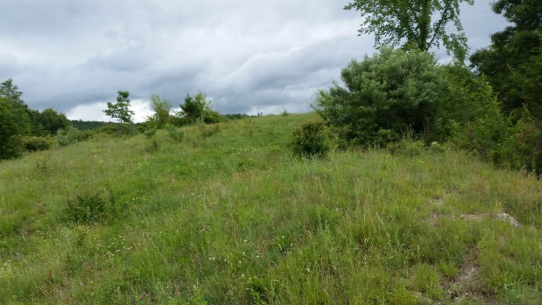
The photos above show examples of desired future conditions with shrub plantings interspersed with open herbaceous vegetation such as native grasses and forbs. Creating shrubland benefits pollinators by improving floral diversity and habitat structure. This habitat type will benefit other wildlife associated with early successional growth. Note: Some plant species pictured above are not native and are not recommended for habitat enhancement practices. Images are provided as examples of open shrubland habitat structure.

Definition and Purpose
Tree/Shrub Establishment (612) is defined by NRCS as establishing woody plants by planting seedlings or cuttings, by direct seeding, and/or through natural regeneration. The purpose(s) of Tree/Shrub Establishment at Ireland Brook Conservation Area is to provide habitat for pollinator and beneficial organisms. Additional considerations include restoring native plant communities, creating habitat for other wildlife, and enhancing vegetative structure. NRCS considers this practice to apply on any site capable of growing woody plants. This practice does not apply to plantings for forage production or to critical area plantings. The resource concern addressed is Fish and Wildlife – Inadequate Habitat (food, cover/shelter, space continuity) and Degraded Plant Condition – Inadequate Structure and Composition.
NRCS practice standards require the following general criteria for all Tree/Shrub Establishment purposes:
- Select one or more species that are suited to soil and site conditions, and appropriate for the planned purpose(s). Refer to the New Jersey Tree and Shrub Planting Guide for choosing the appropriate species planting methods, and additional planting information.
- Determine desired stocking levels for trees and/or shrubs based on ecological characteristics of the site and species, and landowner objectives. Plant, seed, and/or naturally regenerate at densities/rates that reflect anticipated seedling mortality, to achieve desired stocking levels in the established stand. Use NRCS Conservation Practice Standard Tree/Shrub Site Preparation (490) to prepare sites for planting, seeding, or natural regeneration, if conditions are not suitable for establishing the desired plants.
- Use tree/shrub planting to accomplish or supplement forest stand regeneration in locations where natural regeneration of desired species is not possible, or will not meet objectives.
- Select only viable, high quality, and adapted plant materials. Select planting stock that conforms to established seed transfer protocols within the State, and complies with minimum standards accepted by the American National Standards Institute (ANSI). Do not plant any species on the Federal or State invasive species or noxious weed lists.
- Choose appropriate planting dates and handling methods to increase rates of survival. Select planting techniques and timing appropriate for soil and site conditions.
- Alter species selection and/or timing of planting/seeding to minimize potential effects of residual chemical carryover, as needed.
- Evaluate the site to determine if mulching, supplemental water or other cultural treatments (e.g., tree protection devices, shade cards, brush mats, etc.) are needed to assure adequate survival and establishment. Minimize the need for supplemental water and/or nutrients by choosing site-adapted plant materials, planting methods, and planting seasons.
- Where supplemental moisture is needed to achieve tree/shrub establishment use Irrigation System, Microirrigation (441).
- Protect tree and shrub plantings, seeded areas, and naturally regenerated areas, from unacceptable adverse impacts of pests, wildlife, livestock, and/or fire. Protect from pests, as necessary, by applying integrated pest management techniques for pest prevention, avoidance, monitoring, and suppression.
- Removal of products (e.g., trees, biomass, medicinal herbs, nuts, fruits, etc.) is allowed, provided that conservation purpose(s) are not compromised by the loss of vegetation or by harvesting disturbance.
NRCS practice standards require the following additional criteria for habitat for beneficial organisms:
- Plant trees and shrubs that provide habitat and food sources for beneficial organisms, such as pollinators, predatory and parasitic insects, spiders, insectivorous birds and bats, raptors, and terrestrial rodent predators. Select plant species that meet dietary, nesting, and cover requirements for the intended beneficial organisms during the critical period for control of target pests and, if possible, for the entire year.
- Protect beneficial organisms from harmful pesticides. Includes direct exposure and habitat contamination by pesticide drift.
- A custom plant list is provided for this purpose.

Plant Selection
The recommended plant species for Conservation Cover at Ireland Brook Conservation Area were selected for the following criteria:
- Documented or recognized value to a variety of pollinators.
- Beneficial to wildlife.
- Commercial availability from regional seed producers.
- Native status (or locally adapted, non-invasive status).
- Lack of host potential for crop pests and diseases, and lack of weed potential.
- Suitability to local soils, drainage, and other site factors.
- Priority species identified for shrub establishment at Ireland Brook Conservation Area are listed in the provided plant list. If participating in NRCS programs, species substitutions and modifications to the provided plant list must be reviewed to ensure alternatives are site appropriate and that they meet NRCS practice standards.

Ireland Brook Conservation Area – Tree/Shrub Planting (612) Plant List
Common Name  Scientific Name | MatureHeight | Wildlife Habitat and Food Value | Additional Comments
American Witchhazel  Hamamelis virginiana | 20-30’ | Seeds are food for small mammals and birds. | Leaves turn brilliant gold in fall
Sweetspire  Itea virginica | 3-8’ | Attracts a variety of flower visitors. | Leaves attractive red and purple color in fall
Northern Bayberry  Morella pensylvanica | 5-8’ | Leaves remain through winter providing cover; fruit provides winter food for gamebirds and songbirds | Fixes nitrogen and will encourage growth of surrounding plants, make sure to control invasive plants surrounding bayberry
Winged sumac  Rhus copallinum | 5’ | Attractive to bees, especially honey bees and bumble bees; abundant winter fruit | Vibrant fall foliage; bright red winter fruits
Rose-bay rhododendron  Rhododendron maximum | 12’ | Flowers attract a variety of insects, especially bumble bees | Evergreen foliage; large spring flowers
Pinxter Azalea  Rhododendron periclymenoides | 8’ | Flowers attract a variety of insects, especially bumble bees | Attractive spring flowers
Highbush Blueberry  Vaccinium corymbosum | 6-12’ | Attracts numerous native bees | Lush green foliage in summer; yellow, orange, or red fall foliage; reddish stems add ornamental value in winter; edible berries
Maple-leaf Viburnum  Viburnum acerifolium | 3-6’ | Shallow flowers attract small bees, flies, and other flower-visitors | Fall foliage is reddish-purple
Black Chokeberry  Aronia melanocarpa | 10’ | Spring flowers; food source for birds | Purplish-red leaves in fall; edible, tart, berries can be used to make jams or jellies
New Jersey Tea  Ceanothus americanus | 3-4’ | Flowers visited by native bees, flies, butterflies, hummingbirds. | Yellow twigs add color to winter landscape.
Black Huckleberry  Gaylussacia baccata | 1-3’ | Attracts pollinators; important food source for songbirds, gamebirds, and other wildlife | Edible berries
Species on this list tolerate a range of soils, moisture levels (dry-mesic), and light conditions (part shade-full sun). See the Hedgerow Planting (422) for Pollinators: New Jersey Installation Guide provided in the appendix for additional species of native shrubs that benefit pollinators. A copy of this plant list is provided in the appendix of this plan.

Installation Plan and Timeline
Establishing shrubs includes three phases: (1) site preparation; (2) planting, and; (3) follow-up management during establishment. Long-term maintenance is required after the shrub planting is established to maintain its intended conservation purpose and function. If participating in NRCS programs, establish shrubs according to the NRCS Tree/Shrub Planting (612) Practice Standards (see appendix for NRCS NJ guidance documents).

Site Preparation: Basic Instructions
Planting shrubs requires excellent site preparation. Site preparation is one of the most important, though often inadequately addressed, components of project success. It is also a process that may require more than one season of effort to reduce competition from invasive, noxious, or undesirable non-native plants prior to planting. In particular, site preparation should focus on the removal of persistent, perennial weeds (herbaceous and woody). More effort and time spent eradicating undesirable vegetation prior to planting will result in higher success rates in establishing the targeted plant community. Use mowing, strip tillage, and mechanical removal of current vegetation and weeds to prepare the planting area is recommended for this site. Follow the steps below:
- Mow, brush hog, strip-till, and/or mechanically remove current vegetation and weeds throughout shrub planting areas and from adjacent areas to prevent invasion into new planting. Targeted, spot-treatment with non-selective, non-persistent herbicide can be used as needed to eliminate weeds or other competing vegetation.
- Repeat weed control activities for at least one season in areas of high weed pressure to eliminate regrowth. This may require several treatments. Time weed management activities properly – do not allow weeds to set and disperse seed.
- Once adequate weed control is achieved, rake or lightly harrow the areas to be planted to create a smooth, clean surface for installing shrubs.

Planting Method
Once site preparation is completed, transplant container stock in spring or fall after/before frost periods and avoid planting during prolonged periods of hot, dry, or windy weather. Follow the steps below:
- Prior to planting, rake or harrow the planting areas to create a clean surface for installing transplants.
- Pre-drill the appropriate amount of holes, fill holes with compost, and stage plants for placement.
- Irrigate transplants thoroughly immediately after planting. Follow-up irrigation may be necessary during the establishment period, depending on the frequency of natural rain events. Transplants should receive at least 1 inch of water per week during the establishment period.
- One-time mulching with untreated wood chips after planting is recommended to reduce weed competition and retain moisture during the establishment period. To prevent rodent damage, do not mulch within one foot of seedling.
- Use animal guards, tree tubes, or temporary fencing to protect seedlings from deer browse or other animal damage and remove animal guards before they impede growth.

Planting Dates
Plant Material | Spring Planting Dates | Fall Planting Dates
Bare root plants⁺ | Mar. 1 to May 1* | Nov. 1 to Dec. 15**
Containerized stock, ball-and-burlap stock | Mar. 1 to May 15* | Oct. 15 to Dec. 15**
- Planting dates may require adjustment based on local conditions. Avoid planting during prolonged, extreme conditions (e.g., heat, wind).
- When planted during the growing season, most bare root plant materials must be purchased and kept in a dormant condition until planting.
- Spring planting periods may be extended if irrigation is available.
- Frequent freezing and thawing of wet soils may result in frost heaving of plants installed in late fall, if plants have not sufficiently rooted in place. Large containerized and ball-and-burlap stock may be planted in winter months as long as the ground is not frozen and soil moisture is adequate.
For more information on plant materials and planting methods, see:
- The New Jersey Tree and Shrub Planting Guide (provided in the appendix of this plan)
- A Guide to Conservation Plantings on Critical Areas for the Northeast. Available online at https://www.nrcs.usda.gov/Internet/FSE_PLANTMATERIALS/publications/nypmspu11417.pdf

Planting Density
Plant shrubs in clumps (motts). NRCS recommends that 50 plants be included in each 50 ft. diameter motts with 4 motts per acre for a total of 200 shrubs. Space plants 3-6’ apart.

Management During Establishment
Weed control is critical in the first and second years after planting. Prevent weeds from to going to seed in or adjacent to the project area during the first two years after planting. Clearly mark (flag) small seedlings after planting and control weeds within a minimum of 3 ft. diameter around the base of each seedling by mowing, string-trimming, or hand-weeding until the plants are well established. Monitor and remove noxious invasive weed species. Newly transplanted shrubs should receive at least 1 inch of water per week during the first two years of establishment. Using non-treated woodchip or weed-free straw mulch is recommended to help with moisture retention. Protect plants from animal damage using tubes, guards, and/or fence until plants establish.

Long-Term Management
Once shrubs are established, implement a management regime to maintain open habitat and control invasive species. The goal is to maintain diverse shrubland/early successional habitat. Management plans can include methods such as mowing, brush-hogging, prescribed burns, shallow disking, targeted herbicide application, tree removal, or combination thereof. Divide area into patches (e.g., quarters) and rotate management in small sections on a 3-5 year rotation, leaving other sections undisturbed. Adjust management schedules as needed to prioritize treatments in areas where vegetation is becoming uniform (e.g., habitat dominated by woody growth with limited herbaceous openings) or to control invasive species. The goal is to maintain well-mixed patches of native shrubs and herbaceous vegetation. Monitor plant cover in project area and manage according to maintain shrubland habitat characteristics. For reference, shrubland habitat is typically characterized by:
- Shrubs and saplings (~3-15 ft. tall) unevenly distributed among herbaceous openings (forbs and grasses).
- Shrub canopy can range from 30-70% of the cover with individuals or clumps not touching to interlocking (open shrublands = 10-30% shrub cover; closed shrublands > 30% shrub cover).
- Overstory trees may be present, but canopy is mostly open (~5-15 overstory trees/ac. with 10-30% canopy cover).
Based on existing conditions, select an appropriate management option. Common techniques are summarized in the table below, and can be used to guide management. This list is not exhaustive. Consult with a qualified specialist/certified pesticide applicator for specific recommendations on herbicides for invasive species control.
Plant community observation | Management option | Description
Lack of forest edge or forest edge lacking understory/shrub layer | Plant desired species | Install fast-growing native trees and shrubs in clumps or rows along existing field border, forest edge, fenceline, etc. Add forbs and grasses to create herbaceous layer if needed.
Shrubs too dense, uniform in growth, or too many exotic shrubs present | Prescribed burning or grazing | Use fire or graze cattle to reduce shrub density. See notes below on timing of controlled burns.
 | Herbicide spot-treatments | Treat individuals or groups of trees or shrubs to create smaller clumps. Prioritize treatment of invasive or undesired plant species. Use selective herbicide if needed (e.g., grass-selective herbicide to encourage forbs).
Too few canopy trees | Plant desired species | Plant fast growing native trees scattered or in clumps throughout the patch. Keep canopy open.
 | Timber management | Selective thinning of trees into forest to create a feathered edge. Retain existing saplings or install new plants per management goals.
Too much herbaceous cover (want to increase shrub cover) | Mechanical treatment | Reduce frequency and/or intensity of mowing.
 | Prescribed burning or grazing | Reduce frequency and/or intensity of burning or grazing.
 | Plant desired species | Plant a multiple species of fast growing native shrubs in clumps.
Note: These guidelines can be used to manage open habitat on other areas of the property.

Operations and Maintenance
- The following actions shall be carried out to insure that this practice functions as intended throughout its expected lifetime. Early successional habitat will require ongoing maintenance to maintain open habitat, plant health, diversity, and function. The following activities will be planned and applied as needed:
- Burn or mow the area periodically in patches to maintain the health of the plant community and different vegetative growth patterns. Do not conduct maintenance practices and activities during the primary reproductive period of wildlife. Exceptions can be considered to maintain the health of the vegetative community if such exceptions do not conflict with NRCS practices requirements.
- Control access by vehicles and/or equipment during or after tree/shrub establishment to protect new plants and minimize erosion, compaction and other site impacts.
- Inspect the site at an appropriate time following planting, seeding, and/or natural regeneration to determine whether the survival rate for tree and shrubs meets practice and client objectives. Replant or provide supplemental planting when survival is not adequate.
- Inspect the trees and shrubs periodically, and protect them from adverse impacts of insects, diseases, competing vegetation, fire, livestock, wildlife, non-functioning tree shelters and/or weed barriers, etc.
- Control plant species on the Federal or State invasive species and noxious weed lists.

Conservation Cover (327) for Pollinators
Establish and maintain permanent vegetative cover of native wildflowers and bunch grasses that provide pollen- and nectar-rich forage, nesting sites, and overwintering refuge for pollinators. Additional benefits include increased biodiversity, habitat for other wildlife, and landscape beautification.

Current Conditions
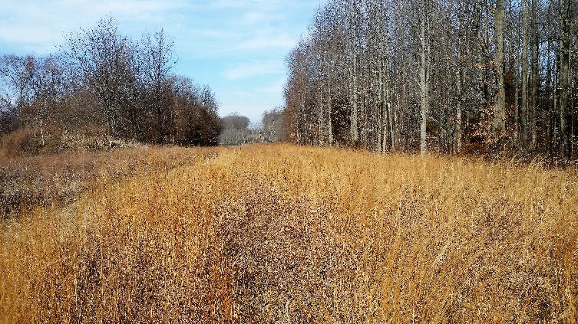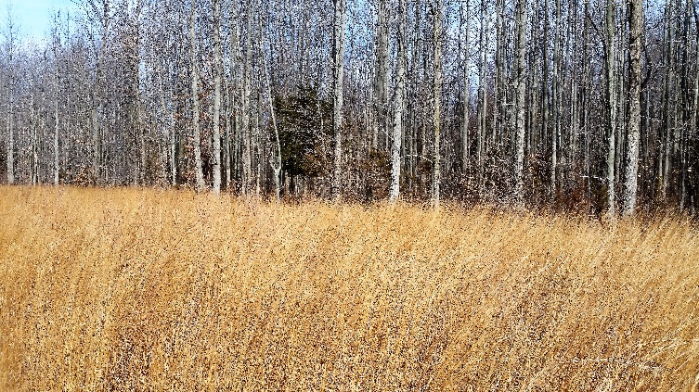
The pictures above show the gas line right-of-way and grassland areas at Ireland Brook Conservation Area. OSCC proposed areas currently managed as grassland on the property as a possible location for pollinator habitat enhancement. These areas can be enhanced by planting diverse wildflower habitat.

Desired Future Conditions
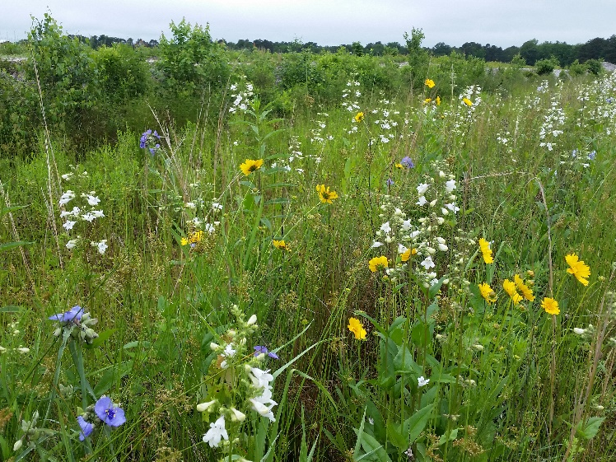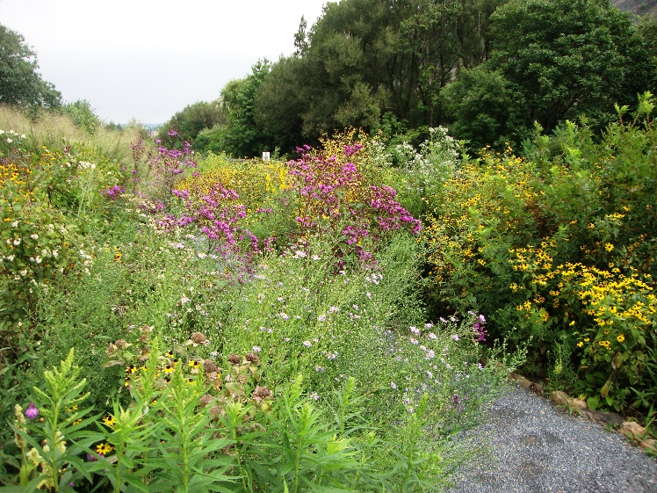
The photos above show examples of desired future conditions at Ireland Brook Conservation Area’s grasslands enhanced with a mix of native wildflowers. Wildflower mixes for pollinators are designed with diversity of native perennial species that bloom throughout the season. Enhancing grasslands with native wildflowers will provide high quality foraging habitat for pollinators compared to the current plant community, which is dominated by grasses.

Definition and Purpose
Conservation Cover (327) is defined by NRCS as establishing and maintaining permanent vegetative cover. The purpose(s) of Conservation Cover on Ireland Brook Conservation Area is to enhance pollinator and beneficial organism habitat. NRCS considers this practice to apply on all lands needing permanent vegetative cover (cropland, odd areas, corners, etc.). This practice does not apply to plantings for forage production or to critical area plantings. The resource concern addressed is Fish and Wildlife – Inadequate Habitat (food, cover/shelter, space continuity)
NRCS practice standards require the following general criteria for all Conservation Cover purposes:
- Select species that are adapted to the soil, ecological sites, and climatic conditions that are suitable for the planned purpose and site conditions.
- Choose seeding rates and planting methods that will be adequate to accomplish the planned purpose.
- Planting dates, planting methods and care in handling and planting of the seed or planting stock shall ensure that planted materials have an acceptable rate of survival.
- Prepare the site by establishing a consistent seeding depth. Eliminate weeds that would impede the establishment and growth of selected species.
- Base the timing and equipment selection on the site and soil conditions.
NRCS practice standards require the following additional criteria for pollinator habitat:
- Plant a diverse mixture grasses and forbs species to promote biodiversity and meet the needs of the targeted species using approved habitat appraisal guides, evaluation tools, and appraisal worksheets.
- Locate habitat plantings to reduce pesticide exposures that could harm wildlife, pollinators, and other beneficial organisms.
- Mowing and maintenance activities shall not disturb cover during the reproductive period for grassland wildlife species (before July 15). Note: Mowing during establishment is permitted.
- A custom seed mix is provided for this purpose.

Plant Selection
The recommended plant species for Conservation Cover at Ireland Brook Conservation Area were selected for the following criteria:
- Documented or recognized value to a variety of pollinators.
- High ratio of forbs to grasses, with a minimum of three species in each bloom period.
- Commercial availability from regional seed producers.
- Native status (or locally adapted, non-invasive status).
- Lack of host potential for crop pests and diseases, and lack of weed potential.
- Suitability to local soils, drainage, and other site factors.
Priority species for wildflower planting at Ireland Brook Conservation Area are listed in the provided seed mix. If participating in NRCS programs, species substitutions and modifications to the provided mixes must be reviewed to ensure alternatives are site appropriate meet NRCS practice standards.
Ireland Brook Conservation Area - Conservation Cover (327) for Pollinators Seed Mix
Common Name | Scientific Name | Percent of mix by seed | Target seed/ft2 | Total lb. | Bloom Period
Blue Eyed Grass | Sisyrinchium angustifolium | 5.0% | 3.00 | 0.23 | Early
Tall White Beardtongue | Penstemon digitalis | 13.0% | 7.80 | 0.17 | Early-Mid
Lance Leaved Coreopsis | Coreopsis lanceolata | 6.0% | 3.60 | 0.71 | Early-MId
Plains Coreopsis | Coreopsis tinctoria | 5.0% | 3.00 | 0.04 | Early-MId
Partridge Pea | Chamaecrista fasciculata | 1.0% | 0.60 | 0.40 | Early-MId
Blackeyed Susan | Rudbeckia hirta | 10.0% | 6.00 | 0.17 | Early-MId
Perennial Blanketflower | Gaillardia aristata | 5.0% | 3.00 | 0.70 | Early-MId
Common Milkweed | Asclepias syriaca | 1.0% | 0.60 | 0.37 | Mid
Butterfly Milkweed | Asclepias tuberosaa | 1.0% | 0.60 | 0.37 | Mid
Wild Bergamot | Monarda fistulosa | 4.0% | 2.40 | 0.08 | Mid
Gray Headed Coneflower | Ratibida pinnata | 4.0% | 2.40 | 0.20 | Mid
Hoary Vervain | Verbena stricta | 4.0% | 2.40 | 0.20 | Mid
Spotted Beebalm | Monarda punctata | 5.0% | 3.00 | 0.13 | Mid
Oxeye Sunflower | Heliopsis helianthoides | 1.0% | 0.60 | 0.25 | Mid
Purple Coneflower | Echinacea purpurea | 5.0% | 3.00 | 1.14 | Mid-Late
Narrowleaf Mountainmint | Pycnanthemum tenuifolium | 6.0% | 3.60 | 0.04 | Mid-Late
Zigzag Aster | Symphyotrichum prenanthoides | 3.0% | 1.80 | 0.03 | Late
Showy Goldenrod | Solidago speciosa | 4.0% | 2.40 | 0.08 | Late
New England Aster | Symphyotrichum novae-angliae | 5.0% | 3.00 | 0.11 | Late
Little Bluestem | Schizachyrium scoparium | 7.0% | 4.20 | 0.91 | Grass
Canada Wildrye | Elymus canadensis | 5.0% | 3.00 | 1.15 | Grass
 | TOTALS: | 100.00% | 60.00 | 7.50 PLS lb per acre
Notes:
All seed mixes must be ordered in Pure Live Seed (PLS)
Seeding rate: 7.5 lb PLS/acre
Percentages indicate % of each species by seed/ft2 (not %weight)
A copy of this seed mix is provided in the appendix of this plan

Installation Plan and TimeLine
Establishing wildflowers from seed includes three phases: (1) site preparation, (2) planting, and (3) follow-up management during establishment. Long-term maintenance is required after the meadow is established to maintain its intended purpose and function. If participating in NRCS programs, establish wildflower habitat according to the NRCS Conservation Cover (327) Practice Standards and Specifications (see appendix for NRCS NJ guidance documents).
Wildflower habitat can be installed in patches over time if seeding large areas is not feasible. If planting in smaller patches, seeding in blocks or irregular blob shapes is preferred over strips, as narrow, linear plantings are more susceptible to weed invasion due to large edge area. Wildflowers and grasses can also be installed using plugs or containerized plants (or a combination of seed and live plants).

Site Preparation: Basic Instructions
Seeding wildflowers requires excellent site preparation. Site preparation is the most important, though often inadequately addressed, components of project success. It is also a process that may require more than one season of effort to reduce competition from invasive, noxious, or undesirable non-native plants prior to planting. Site preparation should focus on the eradication of invasive, persistent perennial weeds. More effort and time spent eradicating undesirable vegetation prior to planting will result in higher success rates in establishing the targeted plant community. Weeds in adjacent areas should also be managed to prevent spread into wildflower plantings. Site preparation methods recommended for this site include mowing, light cultivation, and herbicide treatment. Follow the steps below.
- In early spring, as soon as the field is accessible, mow existing vegetation to the ground.
- Follow mowing with light, shallow disking, scraping, or raking (disturbing only top 2 inches of soil). Deep tillage is not recommended.
- Apply a non-selective, non-persistent herbicide as per label as soon as weeds are actively growing
- From June through September, repeat shallow cultivation each time vegetation regrowth reaches 4-6 inches to eliminate emerging seedlings and deplete the weed seed bank. Do not let weeds go to seed.
- Repeat herbicide applications throughout the spring, summer, and early fall, as needed (whenever emerging weed seedlings reach 4 – 6 inches).
- For any herbicide-resistant weeds, mow the area to prevent flowering and seed development as necessary. Spot-treat resistant weeds with a more effective herbicide, if available.
- If adequate weed control is achieved, plant pollinator seed mix in the fall, waiting at least 72 hours after the last herbicide treatment. If weeds persist, repeat site preparation for an additional season. See reference image on what a well-prepared seedbed should look like.
Note: Do not till. Avoid any ground disturbance that may bring up additional weed seed. An additional year of site preparation is recommended if weed pressure is particularly high. Avoid use of herbicides that are bee-toxic (e.g., Paraquat and Gramoxone).
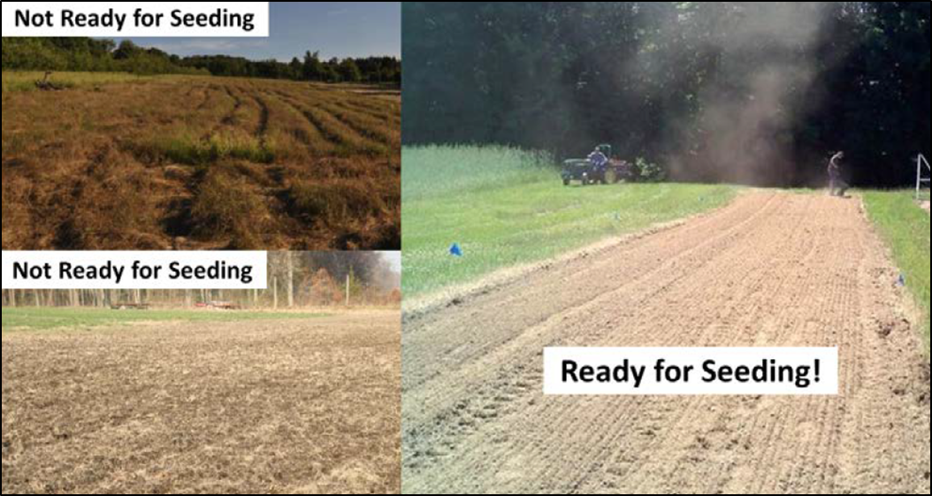
The picture above shows stages of site preparation. Sites with high weed pressure will require one or more seasons of site preparation to control existing vegetation and regrowth. Sites on the left are not ready for seeding and require more effort to eliminate competing vegetation. The site on the right is an example of a site with a well-prepared, weed-free seedbed that is ready for planting.

Planting Method
Broadcast seeding using a hand-crank broadcaster or machine-mounted broadcaster (spinner) is recommended for seeding this wildflower mix. Prior to seeding, create a smooth seedbed by removing all debris, stubble, and thatch from the seedbed. Seed-soil contact is critical for successful establishment. Seed of similar-sizes can be mixed together and bulked up with an inert carrier ingredient such as paving sand, clay-based kitty litter, or pelletized lime. These inert carriers ensure even seed distribution in the mix, visual feedback on where seed has been thrown, and make calibration of seeding equipment easier. Use at least 2 to 3 parts bulking agent for each part seed by volume. Use broadcast seeding equipment that has a flow gate that closes down small enough to provide a slow, steady flow of your smallest wildflower seed and adjust as needed to achieve even coverage.

Planting Dates
Fall dormant seeding (Nov.-early Dec.) is recommended. Time planting to avoid seeding during wet conditions.

Seeding Rate
The seeding rate for the recommended mix is 7.5 PLS lb/ac.

Instructions for Broadcast Seeding
- Once the site is thoroughly prepared per instructions above, remove all remaining plant debris/stubble prior to seeding and create a smooth, lightly packed seedbed. The soil surface can be lightly hand-raked or harrowed to break-up crusted surfaces.
- If the soil is fine and fluffy, roll the area before seeding to lightly pack the seedbed.
- Divide the seed into multiple batches, bulk the seed mix with an inert carrier, using at least 2 to 3 parts bulking agent for each part seed by volume.
- The broadcast seeding equipment can be hand operated or tractor mounted (spin spreaders). Seeders should have a flow gate that closes down small enough to provide a slow, steady flow of the smallest seed. Models with an internal agitator are preferred.
- Make sure flow gate is closed when filling with seed. Begin planting with the flow gate set to the smallest opening and adjust as needed.
- Sow each batch separately walking in different directions (i.e., cross-hatch pattern) and ensure that seed is evenly distributed across the planting area.
- Immediately after seeding roll seeded area with a water-filled turf grass roller (available for rent at most hardware stores) or a cultipacker to press the seed into the soil surface. Do not bury or cover seeds.

Management During Establishment
Weed control is critical in the first and second year after planting. Management practices must be adequate to control noxious and invasive species and may involve tools such as mowing, hoeing, flame-weeding, hand removal, or targeted spot-spray with herbicide. Weeds should be prevented from going to seed in, or adjacent to, the project area to help ensure long-term success. You will not see all the wildflower species in your mix bloom in the first year, as seedlings are putting most of their energy into underground root growth. During this time, it is essential to control weeds that can shade out and out-compete the desired forb and grass seedlings. Follow instructions below:
- In the first year of establishment, whenever canopy (overall vegetation) reaches a height of 12-18 inches, use a brush hog, mower, or string trimmer to trim the meadow to a height of 8 inches. This will reduce competition by fast-growing weeds with slower-growing native wildflower seedlings. Note: A lawn mower is not recommended as the mower height will be too low and native seedlings will be killed. Adjust mowing time as needed to prevent weeds from going to seed.
- Mowing should cease by mid-September, unless additional late-season mowing is needed to prevent weed seed production and dispersal.
- Problem weeds can be removed by hand-pulling, string-trimming, flame-weeding or other preferred method. Mowing restrictions for ground nesting birds are waived during the establishment phase, but will apply once wildflowers are established (after year 2).

Operations and Maintenance
The following actions shall be carried out to insure that this practice functions as intended throughout its expected lifetime. Wildflower plantings require careful management and maintenance for performance and longevity. Wildflower plantings also need to be managed over time to maintain open, early successional characteristics. The following activities will be planned and applied as needed:
- Maintenance measures must be adequate to control noxious weeds and other invasive species.
- Maintenance measures must be adequate to maintain floral diversity and abundance.
- After plants are established, the site will be mown in patches (mowing only 1/3 of the area in a given year) to slow or stop growth of woody plants that may be encroaching on the site and encourage growth of wildflowers.
- Rotate areas being mown each year. Adjust rotation to address weed problems as needed.
- If wildlife habitat enhancement is a purpose, maintenance practices and activities shall not disturb cover during the reproductive period for the desired species. Exceptions should be considered for periodic burning or mowing when necessary to maintain the health of the plant community.
- Do not mow or burn during critical wildlife nesting season (once established).
- Occasional removal of thatch/mower clippings by raking or drag implements to expose understory will help plants reseed.

Hedgerow Planting (422) for Pollinators
Establish and maintain a shrub layer/understory vegetation with a focus on native flowering shrubs and small trees that provide pollen- and nectar-rich forage, nesting sites, and overwintering refuge for pollinators. Many shrub species have earlier bloom periods compared to native wildflowers; therefore, enhancing habitat with native shrubs will address gaps in spring bloom. At Ireland Brook Conservation Area, hedgerow planting along forest edges and riparian areas will enhance the transitional zone (i.e., wildlife feathered edge) by increasing structural diversity and vertical layering of habitats. Additional benefits include expanding the vegetative buffer near streams and wetland areas on the property to improve/protect water quality.

Current Conditions
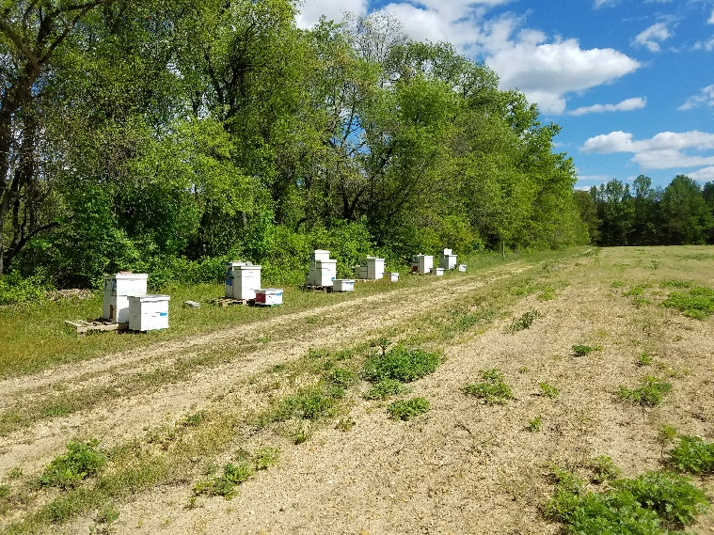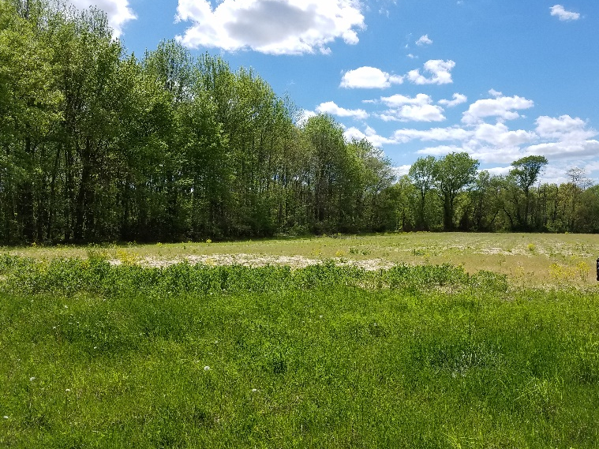
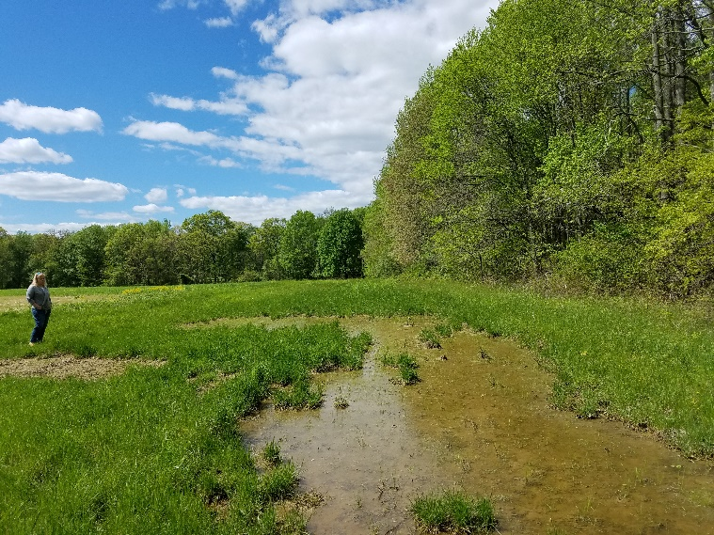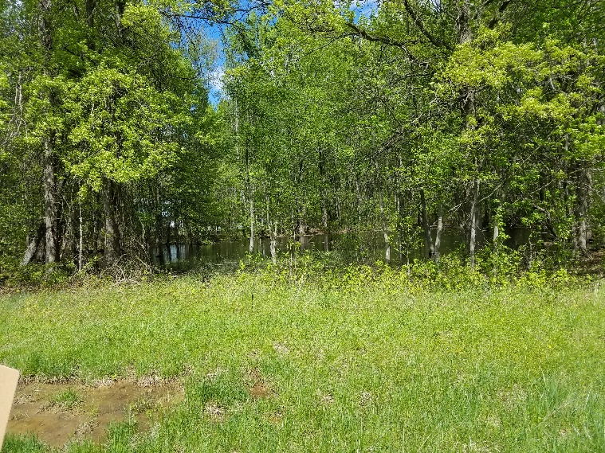
Currently forest edges are dominated by canopy trees. These areas can be enhanced with flowering shrubs, wildflowers, and grasses to improve understory/create a shrub layers to provide habitat for pollinators and other wildlife.

Desired Future Conditions
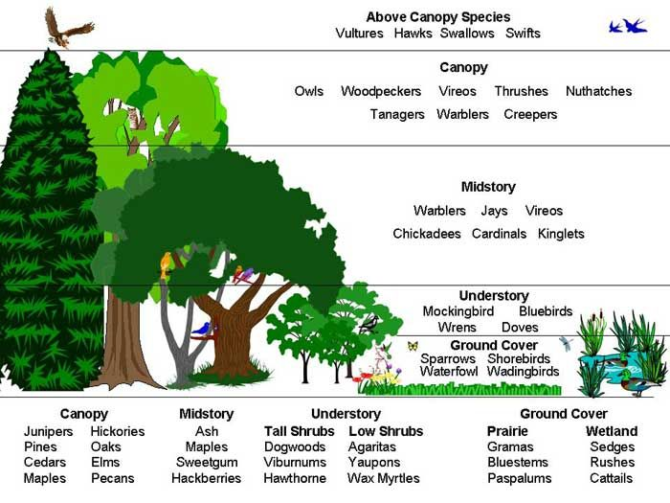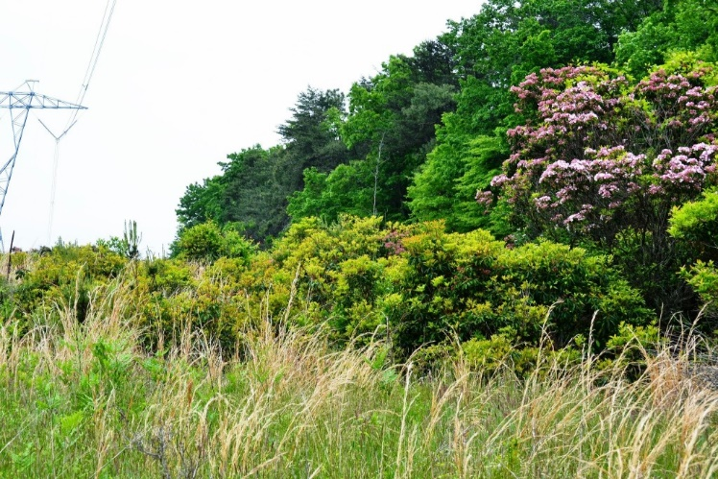
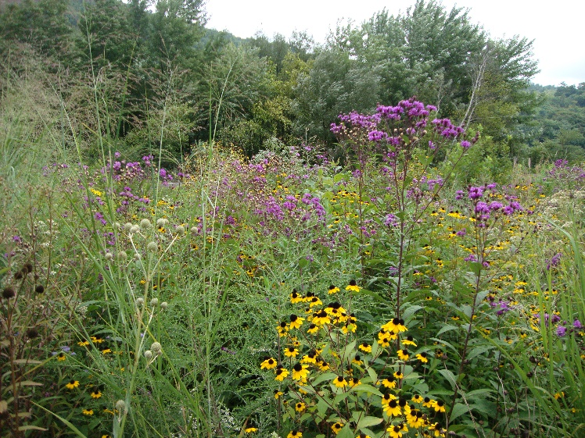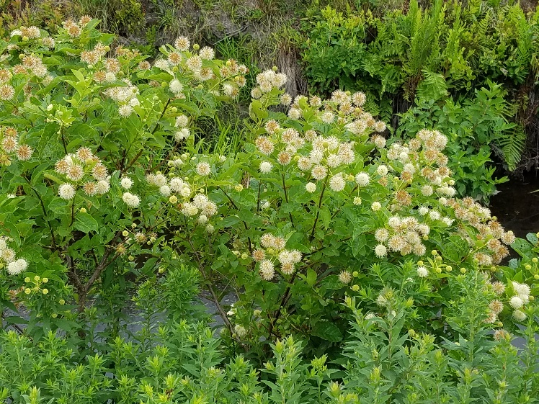
The photos above show examples of desired future conditions at Ireland Brook Conservation Area, with flowering shrubs and wildflowers along woodland edges, field borders, and riparian zones. Planting a shrub and herbaceous layer adjacent to canopy trees will have multiple conservation benefits including increasing native plant diversity, improving stratification of habitat types, expanding the vegetative buffer between crop fields and water courses/wetlands, and farmland beatification.

Definition and Purpose
Hedgerow Planting (422) is defined by NRCS defined as establishment of dense vegetation in a linear design to achieve a natural resource conservation purpose. The purpose(s) of Hedgerow Planting include enhancing pollen, nectar, and nesting habitat for pollinators. NRCS considers this practice to apply wherever it will accomplish at least one of the conservation functions for the intended purpose. The resource concern addressed is Fish and Wildlife – Inadequate Habitat (food, cover/shelter, space continuity) and Degraded Plant Condition - Inadequate Structure and Composition.

NRCS practice standards require the following general criteria for all Hedgerow Planting purposes:
- Hedgerows shall be established using woody plants or perennial bunch grasses producing erect stems attaining average heights of at least 3 feet persisting over winter.
- Plants must be suited and adapted to soil and site conditions, climate, and conservation purpose.
- Species shall be selected that do not host pests or diseases that could pose a risk to nearby crops.
- The practice shall be protected from livestock grazing and trampling to the extent necessary to ensure that it will perform the intended purpose(s).
- Competing vegetation shall be controlled until the hedgerow becomes established. Control shall continue beyond the establishment period, if necessary.
- No minimum width beyond a single row is required except where wildlife food and cover is an objective.
NRCS practice standards require the following additional criteria for Hedgerow Planting for pollinator habitat:
- Hedgerow plants must provide abundant pollen and nectar resources.
- Multiple species with different blooming periods (early spring through late summer) shall be included in the planting. The actual number of species is dependent upon the availability of adjacent flowering plants. Plants that bloom during the same period as adjacent insect-pollinated crops can be excluded.
- Pollinator hedgerows will be protected from pesticides that harm pollinators. If pest control is required, only non-blooming plants will be treated and only pesticides non-toxic to pollinators shall be used.
- A custom plant list is provided for this purpose.

Plant Selection
The recommended plant species for Hedgerow Planting at Ireland Brook Conservation Area were selected for the following criteria:
- Woody plants with high value to pollinators.
- Butterfly host plants.
- A combination of species that bloom early spring through summer.
- Commercial availability from regional seed producers or nurseries.
- Native status.
- Lack of host potential for crop pests and diseases, and lack of weed potential.
- Ease of establishment and suitability to local soils, drainage, and other site factors.
- Priority species identified for hedgerow planting at Ireland Brook Conservation Area are listed in the following tables. If participating in NRCS programs, species substitutions and modifications to the recommended list must be reviewed to ensure alternatives are site appropriate and that they meet NRCS practice standards.

Ireland Brook Conservation Area – Hedgerow Planting (422) Plant Lists

RECOMMENDED SHRUBS FOR WET-MESIC CONDITIONS
Common Name  Scientific Name | Mature Height | Wildlife Habitat and Food Value | Bloom | Notes
Ninebark  Physocarpus opulifolius | 10’ | A variety of bees, wasps, flies, and butterflies visit flowers; larval host plant (41 species); multi-stemmed arching branches provide wildlife cover | Early-mid spring | Adaptable to a wide range of soil and moisture conditions
Pussy willow  Salix discolor | 15’ | Important early spring food source for pollinators; several species of mining bees (Andrena spp.) are specialists on Salix pollen (oligolectic); larval host plant (455 species); birds (e.g., Mallard) feed on buds or catkins; fallen leaves eaten by turtles | Early-mid spring | One of the earliest nectar and pollen sources for wild bees and honey bees; adapted to a range of habitats; responds well to coppicing
Leatherleaf  Chamaedaphne calyculata | 2-5’ | Small bell-shaped flowers attract bees, especially bumble bees; larval host plant (15 species); used by birds and other wildlife for nesting and cover | Mid spring | Evergreen shrub
Smooth arrowwood  Viburnum dentatum | 6-12’ | Nectar/pollen for bees, flies, butterflies, skippers, larval host plant (104 species); high value berries for migratory songbirds and upland gamebirds | Mid-late  spring | Attractive landscape plant with dense foliage and white flower clusters; suckers freely
Silky dogwood  Cornus amomum | 6-10’ | Attracts pollinators; larval host plant (118 species); fruits eaten by songbirds, grouse, turkey, quail; provides wildlife cover | Late spring-early summer | Prefers some shade; produces fruit at 3-5 years of age; attractive white flowers and blue berries; prefers some shade
Red osier dogwood  Cornus sericea | 4-8’ | Larval host plant (118 species); whitish fruit eaten by birds | Late spring-early summer | Bright red stems attractive in winter
Common winterberry  Ilex verticillata | 6-12’ | Tiny white flowers are very attractive to bees, especially honey bees; larval host plant (39 species);long-lasting berries provide winter food for birds | Late spring-mid summer | Dioecious (separate male and female plants), a male must be in the area to pollinate female plants for fruit production
RECOMMENDED SHRUBS FOR WET-MESIC CONDITIONS (continued)
Common Name  Scientific Name | Mature Height | Wildlife Habitat and Food Value | Bloom | Notes
Buttonbush  Cephalanthus occidentalis |  | Excellent mid-summer nectar and pollen source; visited by a variety of pollinators, especially bumble bees; larval host plant (19 species); seeds eaten by ducks and rails | Early-late summer | Unusual, round white flowers; tolerates extended periods of flooding and ponding; prefers permanent saturation
Elderberry  Sambucus canadensis | 5-12’ | Abundant flowers; pithy stems provide nesting sites for solitary bees and beneficial wasps; larval host plant (42 species); berries are important summer food for songbirds including bluebirds, rose- breasted grosbeaks, thrushes | Early-late summer | Showy white flower clusters; tolerates coppicing; jelly and wine can be made from berries
RECOMMENDED GRASSES/SEDGES FOR WET-MESIC CONDITIONS
Tussock sedge  Carex stricta | 3’ | Bumble bees nest in tussocks, larval host plant for butterfly and moth larvae (caterpillars), including eyed brown, mulberry wing, black dash; provides habitat for wildlife, including frogs, toads, salamanders, ducks, herons, rails, snipes; birds use leaves and stems for nests and feed on seeds | May-June | Grass-like
Fox sedge  Carex vulpinoidea |  |  | July-Aug | Grass-like; fox sedge can be aggressive
Riverbank wildrye  Elymus riparius | 2-4 | Foliage eaten by wildlife in early spring | July | CS grass; establishes quickly; tolerates shade; stabilizes soil; short-lived
RECOMMENDED WILDFLOWERS FOR WET-MESIC CONDITIONS
Including wildflowers in hedgerows (herbaceous layer) is optional, but it is encouraged to maximize the diversity of plants for pollinators. The following species are recommended for this purpose:
New York ironweed (Vernonia noveboracensis), grass-leaved goldenrod (Euthamia graminifolia), bottle gentian (Gentiana andrewsii), New England aster (Symphyotrichum novae-angliae), Culver’s root (Veronicastrum virginicum), monkey flower (Mimulus ringens)

Ireland Brook Conservation Area – Hedgerow Planting (422) Plant Lists
RECOMMENDED SHRUBS FOR DRY-MESIC CONDITIONS
Eastern redbud  Cercis canadensis | 15–30' | Early source of nectar/pollen for pollinators; larval host plant (124 species); nesting material for leafcutter bees; seeds eaten by quail, pheasants | Early spring | Showy pink flowers in very early spring lasting for 2-3 weeks; leaves emerge with a reddish color
Smooth serviceberry  Amelanchier laevis | 20’ | Early source of nectar/pollen for pollinators; larval host plant (19 species); fruits eaten by turkey, grouse, songbirds | Early spring | Small tree or shrub; usually multi-stemmed; other characteristics similar to Canadian serviceberry
Canadian serviceberry  Amelanchier canadensis | 6-20’ | Early source of nectar/pollen for pollinators; larval host plant (19 species); fruit is eaten by orioles, cardinals, thrushes, catbirds, woodpeckers, waxwings, robins | Early-mid spring | One of the earliest blooming trees in the spring, yellow and gold foliage turns red-orange in the fall; edible fruit; very resistant to deer browse.
Spicebush  Lindera benzoin | 12’ | Larval host plant (11 species); mammals and birds eat fruits, buds, twigs | Early-mid spring | Spicy scented flowers and leaves; shiny red fruits; establishes quickly
Allegheny blackberry  Rubus allegheniensis | 3-6’ | Nectar/pollen for pollinators; pithy stems provide nesting sites for solitary bees and wasps; larval host plant (163 species); fruits eaten by over 40 species of birds including woodcock, turkey, grouse, also by many mammals | Mid-late  spring | Edible fruit
Cockspur hawthorn  Crataegus crusgalli | 20-30’ | Attracts honey bees and native bees; larval host plant (168 species); fruits eaten by songbirds, gamebirds, excellent wildlife cover | Mid spring-early summer | Flat clusters of white flowers followed by bright red fruits; fruits persist in winter providing food for birds; leaves turn bronze to red in the fall; has thorns
Pasture rose  Rosa carolina | 5’ | Pollen and nesting materials for bees; larval host plant (44 species); fruits eaten by songbird | Mid spring-mid summer | Edible fruit—rose hips high in vitamins (C, E, and K)
Gray Dogwood  Cornus racemosa | 10’ | Attracts pollinators; larval host plant (118 species); fruit eaten by grouse, pheasant | Late spring | Attractive small white flower clusters and white fruits
Black huckleberry  Gaylussacia baccata | 1-2’ | Nectar/pollen for pollinators; larval host plant (44 species); fruits eaten by songbirds, grouse, quail, turkey | Late spring-mid summer | Edible fruit
RECOMMENDED GRASSES FOR DRY-MESIC CONDITIONS
Little Bluestem  Schizachyrium scoparium | 1-3’ | Provides nesting cover for bumble bees; larval host plant for several species of skipper butterflies; cover and seeds for a variety of wildlife. | WS bunch grass | Reddish-tan color in fall, persisting through winter snows
Canada wildrye  Elymus canadensis |  | Food and cover for wildlife | CS bunch grass | Prefers partial shade; seedlings establish quickly, but are not highly competitive with other grasses
RECOMMENDED WILDFLOWERS FOR DRY-MESIC CONDITIONS
Including wildflowers in hedgerows (herbaceous layer) is optional, but it is encouraged to maximize the diversity of plants for pollinators. The following species are recommended for this purpose:
Lanceleaf coreopsis (Coreopsis lanceolata), anise hyssop (Agastache foeniculum), common milkweed (Asclepias syriaca), blue wild indigo
(Baptisia australis), perennial lupine (Lupinus perennis)
Notes:
- Plant lists provide recommended species for wet-mesic conditions and dry-mesic conditions. Select species that match conditions in areas where hedgerows are being installed.
- Select a combination of shrubs with different bloom periods.
- Incorporate native grasses and sedges along shrub rows to create a shrub layer and herbaceous layer (i.e., multi-layer hedgerow)
- For NRCS programs, Hedgerow Planting (422) practice standards do not require the inclusion of wildflowers, but adding wildflowers is encouraged. The recommended species of wildflowers listed in the table can be interspersed with shrubs and grasses for a more diverse hedgerow that blooms all season. Using live plants (e.g., plug, containers) is recommended over seeding for hedgerow practices.

Installation Plan and Timeline
Establishing a hedgerow includes three phases: (1) site preparation; (2) planting, and; (3) follow-up management during establishment. Long-term maintenance is required after the hedgerow is established to maintain its function. If participating in NRCS programs, establish wildflower habitat according to the NRCS Hedgerow Planting (422) Practice Standards and Specifications (see appendix for NRCS NJ guidance documents).

Site Preparation: Basic Instructions
Planting hedgerows requires excellent site preparation. Site preparation is one of the most important, though often inadequately addressed, components of project success. It is also a process that may require more than one season of effort to reduce competition from invasive, noxious, or undesirable non-native plants prior to planting. In particular, site preparation should focus on the removal of persistent, perennial weeds (herbaceous and woody). More effort and time spent eradicating undesirable vegetation prior to planting will result in higher success rates in establishing the targeted plant community. Use mowing, strip tillage, and mechanical removal of current vegetation and weeds to prepare the planting area is recommended for this site. Follow the steps below:
- Mow, brush hog, strip-till, and/or mechanically remove current vegetation and weeds for length of hedgerow planting area.
- Repeat if needed in areas of high weed pressure to eliminate any regrowth.
- Rake or lightly harrow the strip to create a clean surface for installing transplants.

Planting Method
Transplant container stock in spring or fall after/before frost periods and avoid planting during prolonged periods of hot, dry, or windy weather.
- Install shrubs spaced 6 ft. apart along the length of the planting area. If installing multiple row plantings, use 10-15 ft. spacing between rows. Grasses and windflowers can be interspersed along shrub row.
- Prior to planting, rake or harrow the strip to create a clean surface for installing transplants.
- Pre-drill the appropriate amount of holes, fill holes with compost, and stage plants before planting.
- Irrigate transplants thoroughly immediately after planting. Follow-up irrigation may be necessary during the establishment period, depending on the frequency of natural rain events. Transplants should receive at least 1 inch of water per week during the establishment period.
- One-time mulching with untreated wood chips after planting is recommended to reduce weed competition and retain moisture during the establishment period. To prevent rodent damage, do not mulch within one foot of seedling.
- Use animal guards, tree tubes, or temporary fencing to protect seedlings from deer browse or other animal damage and remove animal guards before they impede growth.

Management During Establishment
Weed control is critical in the first and second years after planting. Prevent weeds from to going to seed in or adjacent to the project area during the first two years after planting. Clearly mark (flag) small seedlings after planting and control weeds within a minimum of 3 ft. diameter around the base of each seedling by mowing, string-trimming, or hand-weeding until the seedlings are well established. Monitor and remove noxious invasive weed species that appear in the hedgerow. Newly transplanted shrubs should receive at least 1 inch of water per week during the first two years of establishment. Protect plants from animal damage.

Operations and Maintenance
The following actions shall be carried out to insure that this practice functions as intended throughout its expected lifetime. Hedgerows will require ongoing maintenance to maintain plant health, diversity, and function. The following activities will be planned and applied as needed:
- Vegetation shall be maintained to ensure continued control of odor movement and chemical drift.
- Supplemental planting may be required if plant survival is too low to produce a continuous hedgerow.
- Vegetation shall be protected from unwanted fire and grazing throughout its life span.
- Pests shall be monitored and controlled.
- Renovation activities shall be scheduled to prevent disturbance during the wildlife nesting season.

Pesticide Protection for Pollinators
With growing interest in installing pollinator habitat, it is very important to manage the habitat and surrounding areas to reduce pesticide contamination. There is a growing body of evidence demonstrating that pesticides can and do contaminate pollinator habitat at levels that could harm native bees and butterflies, as well as honey bees placed in the area. Pesticides have been found at hazardous contamination levels in habitat immediately adjacent to agricultural fields as well as in areas further from agricultural sites, although not all pesticide contamination in these more distant sites is from agricultural uses.
Pesticide risk mitigation is an important component of successful pollinator conservation practices. This can be achieved by instituting a combination of measures such as incorporating non-chemical options into pest management plans, eliminating prophylactic and other pesticide uses, and instituting risk mitigation efforts that limit movement of pesticides into habitat. If pesticide risks cannot be managed, habitat should not be installed.

Priority Pesticide Concerns
While a wide range of pesticides could pose risk to pollinators, pesticides that are pose high risks and are of high concern. Some priority concerns are summarized below. Additional information on pesticide toxicity, mitigation techniques, and how to include pollinator/beneficial insect protection in IPM programs can be found in the supporting documents and references listed at the end of this section.

Insecticides
- In general, insecticides are more acutely toxic to insect pollinators than other pesticides. Insecticides of particular concern worth noting are neonicotinoids and insect growth regulators (IGRs).
- Neonicotinoids are a high priority concern because of their systemic nature, persistency, toxicity, and widespread use. They have been linked with a number of debilitating, sublethal effects and bees can be exposed to toxic levels months to years after an application.
- Insect Growth Regulators (IGRs) are generally classified as lower toxicity relative to other insecticides. However, new data are showing risk that warrants caution because toxicity assessments are performed on adult bees, while the harm from IGRs is to immature insects.
- Bees are often exposed to pesticide mixtures. For some pesticide combinations there is evidence demonstrating that the mixture is more toxic than the sum of the two pesticides.

Fungicides
- While most fungicides are characterized as practically nontoxic to bees, they are now being linked with a number of harmful effects to bees.
- Of the various fungicide classes, the DeMethylation Inhibitor (DMI) fungicides have been linked with concerns for pollinators, including increased risk of disease and synergism with some insecticide classes.

Herbicides
- Herbicides in general can limit forage for pollinators (e.g., removes flowering plants from farm fields, borders, etc.).
- Due to their tendencies to drift, the synthetic-auxin herbicides, like dicamba and 2,4-D, have been responsible for injury to nontarget plants. Now research has found that low concentration drift of the synthetic-auxin herbicide dicamba can cause plants to produce fewer flowers and also reduce pollinator visitations.

Common Ways Pesticides can Move into Habitat
- Drift during or immediately after a pesticide application (including dust that drifts when coated seeds are planted).
- Volatilization, when the pesticide turns into a vapor and moves with air, sometimes miles off-site.
- Movement with water into habitat and subsequent uptake by pollinator attractive plants.
- Wind erosion, when contaminated soil is blown off-field,
- Pesticide use in pollinator habitat also must be considered. In particular, habitat can become contaminated from:
- Management of pest issues that arise in habitat.
- Uptake of residual pesticides from prior pesticide applications on site.

Guidance to Protect Habitat from Pesticide Contamination
Avoid using pesticides with active ingredients that are highly toxic to pollinators and beneficial insects. When there is a demonstrated need for pesticide application, chose the least toxic option, do not apply to blooming plants, and take all precaution to prevent or reduce drift.
When planning to create, enhance, or restore habitat it is imperative to take steps to protect pollinators from the pesticide use on your own property and use by adjacent landowners. Basic instructions for reducing contamination of habitat are summarized below.
- Separate habitat from areas receiving treatment with a pesticide-free buffer. While the appropriate size of a setback or pesticide-free area is dependent upon numerous site specific factors, at a minimum, habitat should be:
  - 40 feet (12 meters) from most ground-based pesticide applications, or
  - 60 feet (18 meters) from the use of air blast sprayers.
  - Because of the particular concerns over the effects of neonicotinoids, at a minimum, the pollinator habitat should be: 125 feet (38 meters) from crops treated with nitroguanidine neonicotinoids, including those planted with coated seeds, with the 40 to 60 feet closest to the habitat free of all pesticides (see above).
- Sites should not receive overspray from aerial pesticide applications.
- If there are predominant winds from one direction, especially during seasons when pesticides are used, select a habitat site that is upwind of pesticide use, unless that area has other drawbacks that do not make it suitable for habitat.
Additional mitigation techniques are detailed in the resources below:
- Creating and Maintaining Healthy Pollinator Habitat: Guidance to Protect Habitat from Pesticide Contamination. Available online at: http://www.xerces.org/wp-content/uploads/2016/10/ProtectingHabitatFromPesticideContamination_oct2016-02.pdf
- Preventing or Mitigating Potential Negative Impacts of Pesticides on Pollinators Using Integrated Pest Management and Other Conservation Practices. Available online at: https://directives.sc.egov.usda.gov/opennonwebcontent.aspx?content=34828.wba
- How to Reduce Bee Poisoning from Pesticides (2nd ed.). Available online at: https://catalog.extension.oregonstate.edu/sites/catalog/files/project/pdf/pnw591.pdf

Monitoring and Record Keeping
Monitoring the success of conservation activities is an important part of assessing conservation effectiveness. Monitoring should include documentation of:
- Dates of first flowering for each of the pollinator-friendly forage plant species;
- Specific pollinators, plants visited, and time-frame (date range) of visits;
- Evidence of ground-nesting and wood-nesting bee activity; and
- If providing crop pollination services, record crop yields
Protocols and data collection forms for monitoring plants (bloom phenology) and bee visitation are included in the Streamlined Bee Monitoring Protocol for Assessing Pollinator Habitat provided in appendix of this plan.

Attachments
The following references and supporting documents are included in the appendix of this plan:
- USDA NRCS Property Map T 1219, 757
- USDA NRCS Property Map T 291
- Farm Layout Map
- Soils Map
- Custom Soils Report
- Landscape Project Vernal Habitat Map
- Landscape Project Water Bodies Map
- Pollinator Habitat Assessment Form
- Conservation Practice Map T 1219, 757
- Conservation Practice Map T 291
- Tree/Shrub Establishment (612) Plant List
- Tree/Shrub Establishment (612) Practice Standard
- NJ Tree and Shrub Planting Guide
- Conservation Cover (327) Custom Seed Mix
- Conservation Cover (327) NRCS Practice Standards
- Conservation Cover (327) for Pollinators Installation Guide: New Jersey
- Hedgerow Planting (422) Plant List
- Hedgerow Planting (422) NRCS Practice Standards
- Hedgerow Planting (422) for Pollinators Installation Guide: New Jersey
- Creating and Maintaining Healthy Pollinator Habitat: Guidance to Protect Habitat from Pesticide Contamination
- Streamlined Bee Monitoring Protocol for Assessing Pollinator Habitat

